**Empirical Test of CAPM in Shanghai Securities Market: 2017-2022**

**Introduction**

The Capital Asset Pricing Model (CAPM) is a financial theory that seeks to determine the expected return on an investment, taking into account the risk-free rate, the expected return of the market, and the asset's sensitivity to market fluctuations. CAPM has been an essential tool in finance for portfolio management, risk assessment, and investment decision-making since the 1960s.

The Chinese stock market, as an emerging market, has experienced rapid growth and significant volatility in recent years. The Chinese stock market is known for its volatility, with frequent fluctuations in stock prices. CAPM enables investors to assess the risks associated with these fluctuations and make informed investment decisions. With the increasing number of Chinese companies listed on stock exchanges, CAPM can help investors optimize their portfolios by diversifying across different industries and assets. CAPM can also be used to evaluate the risk and return profiles of Chinese stocks in a global context. This is particularly important for international investors who seek exposure to emerging markets like China.

**Method**

**2.1 CAPM Model**

CAPM decomposes the return of assets into risk-free income and risk income, and believes that the only source of risk income is market risk. The equation is:

$$r_{i}=r_{f}+β×(r_{m}-r_{f})$$

Where $r_{m}$ stands for market return, $r_{f}$ stands for risk-free return, thus $(r_{m}-r_{f})$ is market premium.

$β$ is systematic risk, we can use statistic knowledge to calculate:

$$β=\frac{Cov(r_{m},r_{f})}{σ_{rm}^{2}}$$

**2.2 Fama-Macbeth Regression Method**

The Fama-MacBeth regression is a statistical methodology used in finance and economics to assess the relationship between risk factors and asset returns. It is a two-step approach designed to overcome potential issues of multicollinearity in cross-sectional data. The main objective of this method is to estimate the risk premia associated with various risk factors and determine their significance in explaining the cross-sectional variation in asset returns. We summarize this regression into three steps

* 1. Using the weekly rate of return of the first period, perform time series regression on individual stocks, calculate β, sort and group into 10 groups.
* 2. Using the weekly rate of return in the second period, re-apply the time series regression to calculate the portfolio β.
* 3. Finally, use the combined average return and β of the third period to perform cross-sectional regression.

**Data**

**3.1 Individual stock return**

In order to pay attention to whether China's stock market in recent years conforms to the CAPM model, we selected all A-share stocks from January 2017 to December 2022, and the stock return rate is directly derived from CSMAR which is derived by:

$$r_{i,t} = \frac{P_{i,opening}-P_{i,opening}}{P_{i,opening}}$$

**3.2 Market return**

Since all A-share stock markets are used, we choose the CSI 300 Index as the market return rate, which has a higher coverage than the SSE 180 Index and is more appropriate to the actual market return rate.

**3.3 Risk-free return**

In this project, we use Interest Rate for bank time deposit as our interest rate, we decompose anal rate into weekly rate.

**Result**

**4.1 Individual stock regression**

According to the Fama-Macbeth framework, it is essential to compute the β values utilizing the initial panel dataset, specifically the first 103 weeks in this research endeavor. We choose to display ten stocks regression from different β group.

T**able 1 Time series regression results of the first period of sample stocks**

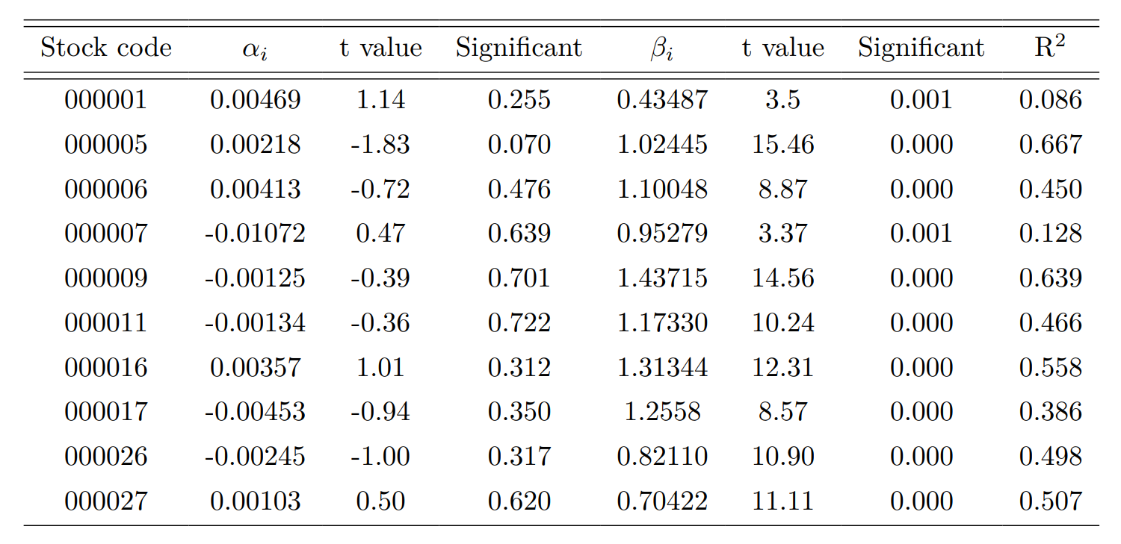

The table provided demonstrates that certain companies exhibit substantial alpha coefficients, indicating that individual stocks are influenced by potent factors besides systemic risk when it comes to stock returns. Simultaneously, R-squared for the individual stock regression analysis appears to be relatively low, signifying that a considerable portion of the influencing factors has not been adequately accounted for in the model. Thus, it is crucial for future studies to explore additional variables and refine the analytical methodology to attain a more comprehensive understanding of the underlying determinants of stock returns in the context of the Fama-Macbeth theory.

**4.2 Portfolio regression**

Owing to the considerable unsystematic risk associated with individual stocks, the relationship between return and risk is susceptible to distortion. To mitigate some of this unsystematic risk, the β values generated during the initial period of individual stocks are classified into ten distinct groups based on the magnitude of the beta coefficient. Subsequently, the excess returns of these groups are computed using the arithmetic mean method. Time-series regression analysis is then performed on the ten portfolios to derive the respective β values.

From CAPM, we must have:

$$r_{p,t}=r_{f,t}+β_{p}×(r_{m,t}-r_{f,t})$$

Then we can rewrite it for simplify regression:

$$r_{p,t}-r_{f,t}=α_{p}+β_{p}×(r_{m,t}-r_{f,t})$$

Instead of testing the intercept is significant on $r_{f,t}$，we can know test if intercept significant on 0, that is ${H_{0}: α}_{p}=0$

**Table 2 Time series regression results of the second period of stock portfolio**

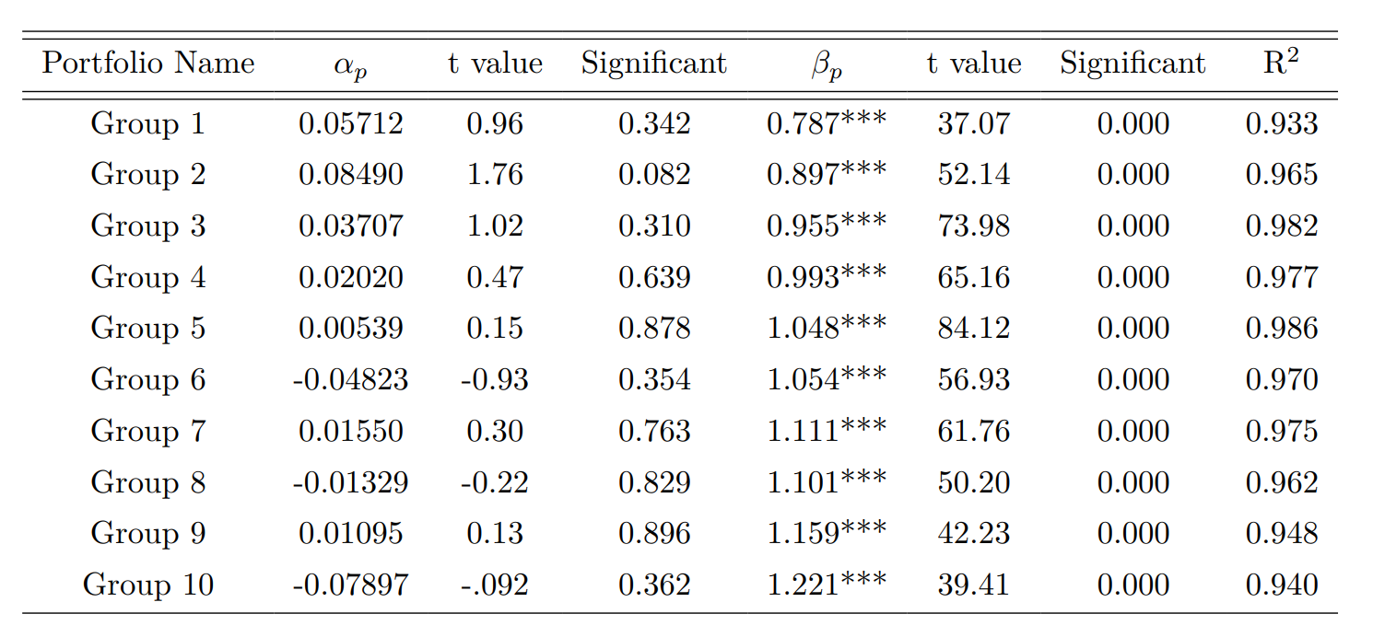

Table 2 reveals that the beta coefficients for these portfolios are relatively consistent, predominantly converging around the value of 1. Furthermore, the statistical significance levels are predominantly low, which suggests a significant influence of stock market returns on individual stock returns. The coefficient of determination (R-squared) values for all ten regressions exceeds 0.9, indicating an exceptional fit between the observed and predicted data points. Additionally, the intercepts (alpha values) are statistically insignificant in 90% of the cases, with only the second group displaying significance at the 90% confidence level. Consequently, it can be inferred that systematic risk is the sole factor correlated with stock returns, and no other driving forces play a significant role.

**4.3 Cross-sectional regression**

We use the second-period beta portfolio to calculate the regression of the third-period portfolio return on market excess returns.

We first compute expected value for ten portfolio premiums:

$$E(r_{p,t}-r_{f,t})=\frac{1}{T}\sum_{t=1}^{T}{(r_{p,t}-r_{f,t})}$$

Then we run cross-sectional regression on the computed portfolio premium and last term β:

$$E(r_{p,t}-r_{f,t}) = γ_{0}+γ_{1}β_{p}+ε_{p}$$

**Table 3. Cross-sectional regression results of the third period of stock portfolio**

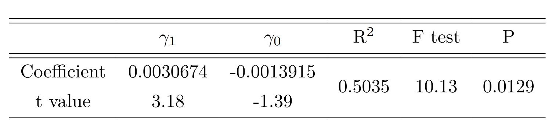

Table 3 shows that $γ_{1}$ = 0.0030674 and t-value is 3.18, which means $β_{p}$ and $E(r_{p,t}-r_{f,t})$ are significantly positively correlated, that is with higher risk, the expected premium is becoming higher. It also shows that $γ_{0}$ is not significant, we can’t reject the null hypothesis that $γ_{0} = 0$. It fits well for CAPM that we can’t conclude more about there is other driving factors affecting expected premium.

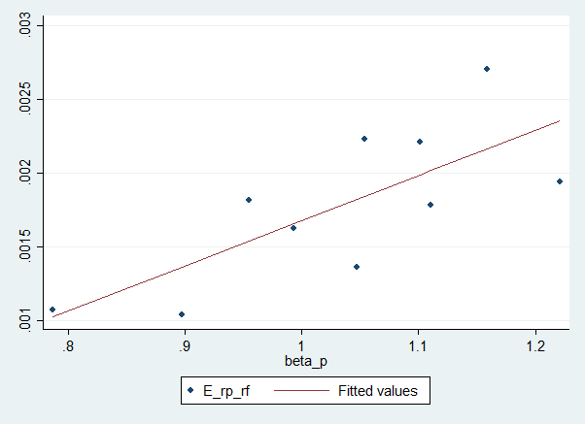

**Figure 1 Cross-sectional regression scatter plot**

From the graph, we can also see that with β increasing, the expected premium always increasing, the regression explains well.

**Discussion**

The results derived from the empirical analysis demonstrate a discernible positive linear association between the return on investment and the associated risk, which fundamentally aligns with the conclusions drawn from the Capital Asset Pricing Model (CAPM). Post-2017, the stock market within my nation has exhibited a considerable degree of stability, accompanied by a progressive enhancement in investor sophistication. Concurrently, there has been a sustained escalation in the representation of institutional investors in the domestic stock market, thereby fostering its ongoing maturation. Consequently, the equilibrium between risk and return in investment endeavors has experienced a marked amplification.

**Limitation**

The most critical limitation of our project is that we only have one cross-sectional regression. With Fama-Macbeth Regression Method, we can do more about the third cross-sectional regression. Instead of computing expected premium for whole third period, it can be broken down into a number of discrete chunks that each consist of a few weeks. For instance, the remaining 103 weeks could be divided into three 34-week chunks. To obtain the new β and determine the average excess return of each portfolio in the first part, we run time series regression on the first part. We may now use the prior β to regress with the average excess return of this part, and use the excess return of this part to regress with the following part. We can obtain more cross-sectional regressions following this repetition. By making better use of the data, it is possible to determine both the long- and short-term consequences of CAPM.